### Subflow user-defined nodes

**Introduction:**

Create a subflow in a static library and then package it as a user-defined node that can be accessed through the IBM App Connect Enterprise Toolkit node palette. The subflow can then be used in a message flow by adding the user-defined node to the flow.

Two roles of users exist, who can use the capability of subflow user-defined nodes that are developed in a static library

1. Subflow user-defined node authors
2. Subflow user-defined node consumers

**Subflow user-defined node authors :**

Subflow user-defined node authors who can develop test, and package a subflow user-defined node that is used for a specific purpose. Subflow user-defined node authors do the following tasks:

* Develop and test subflow user-defined nodes.
* Package and distribute subflow user-defined nodes.

Subflow user-defined node author, you develop a subflow user-defined node by first creating a subflow in a static library. Then, add nodes in the subflow so that the subflow serves a specific purpose. You then test the subflow user-defined node by adding the subflow to a message flow and testing the message flow. After you verify the behavior of the subflow user-defined node, you generate a packaged subflow user-defined library from the static library that contains the subflow user-defined node that you developed. The packaged subflow user-defined library is in the form of a .zip file, which you distribute to subflow user-defined node consumers who want to install your subflow user-defined node to use in message flows.

**Subflow user-defined node consumers :**

Subflow user-defined node consumers are developers who want to use subflow user-defined nodes in their message flows.

As a subflow user-defined node consumer, if you install a subflow that is packaged as a user-defined node within a static library.

* The subflow node icons appear in the palette and you can include them in your message flows.
* The contents of the user-defined-node are hidden. The IBM App Connect Enterprise Toolkit and the IBM App Connect Enterprise web user interface display the subflow as a single node.
* You can deploy message flows that use subflow user-defined nodes as source deployment. It is not necessary to compile them inline to produce a cmf in the BAR file.

**Procedure:**

Go to Applications and create a static library.Give the library name and click on finish.

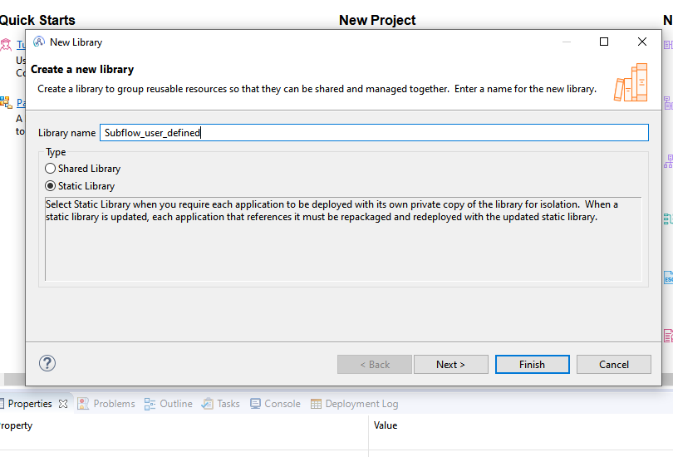

Next create a subflow in that static library.And click on Finish.

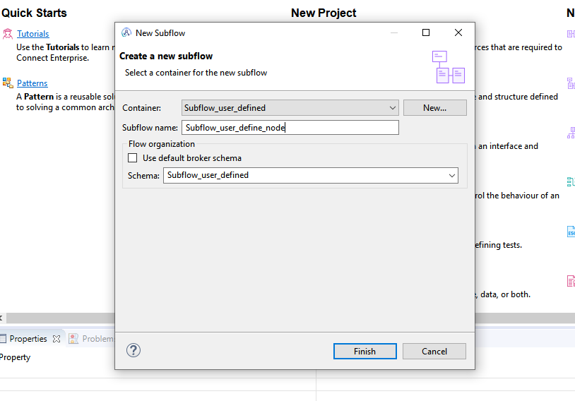

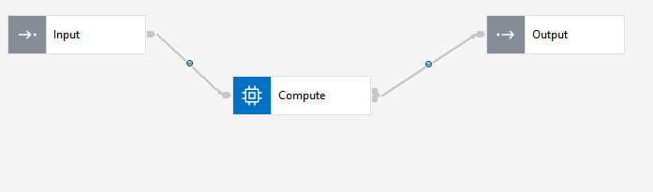

In compute node I am going to perform xml to json conversion.

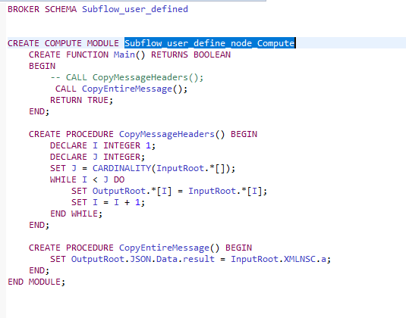

Right click on static library select Subflow user-defined node option and then select set palette category.

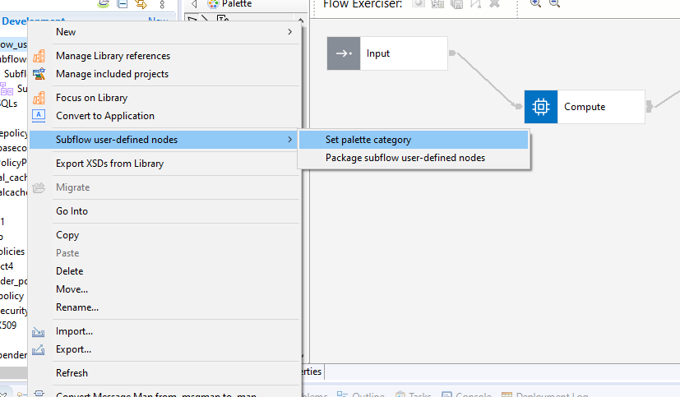

You can select your own icons by selecting import from file system or import from workspace.

Or else you can set the default icons.And click on finish.

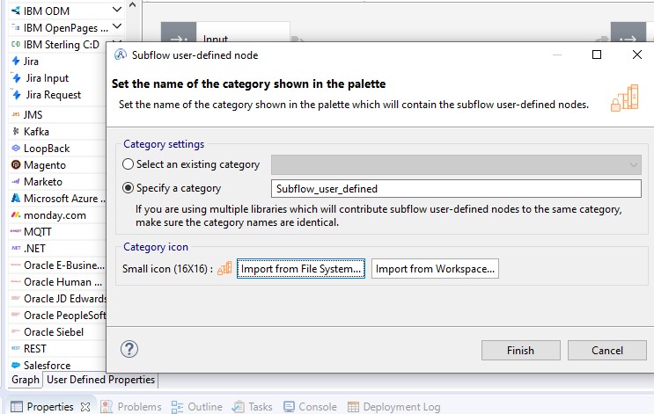

Go to the node palette area and right click select customize option there you can find your created application .

Select that name and uncheck the Hide property.And click OK.

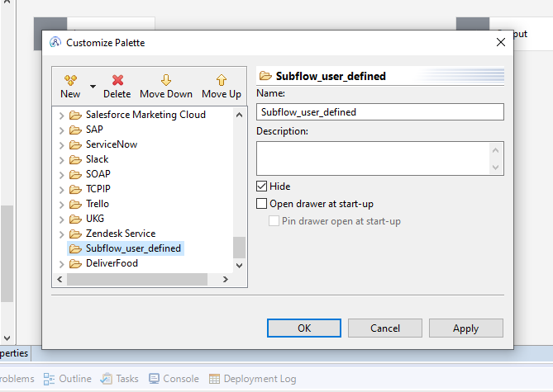

After that go to the subflow and add to the palette.

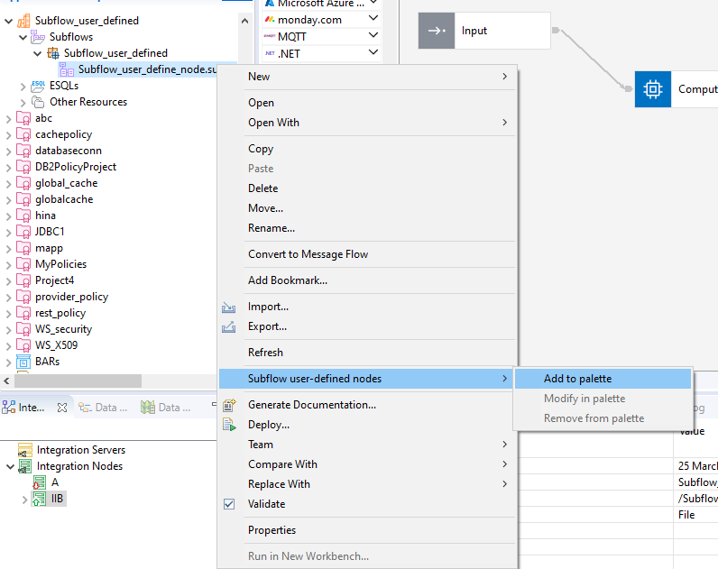

You can set the icon from file system or you can set default one and then click on finish.

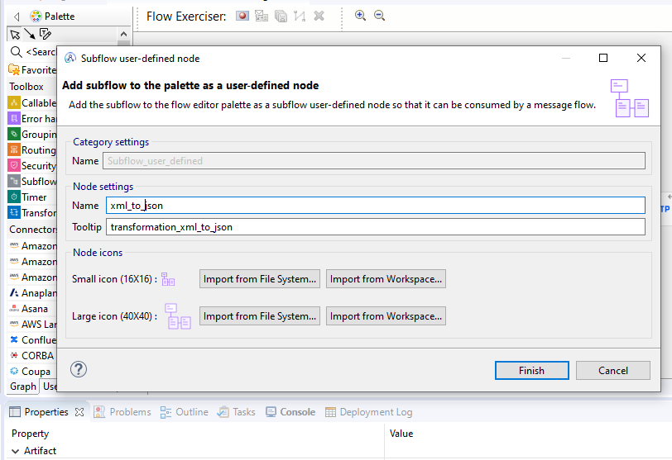

Static library and subflow will be added to your palette.

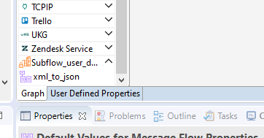

Create an Application to use subflow.

Drag the subflow from the palette.

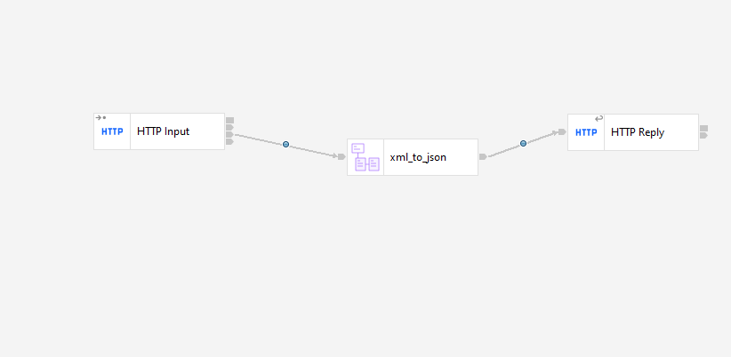

Start the message flow exerciser and deploy the application.

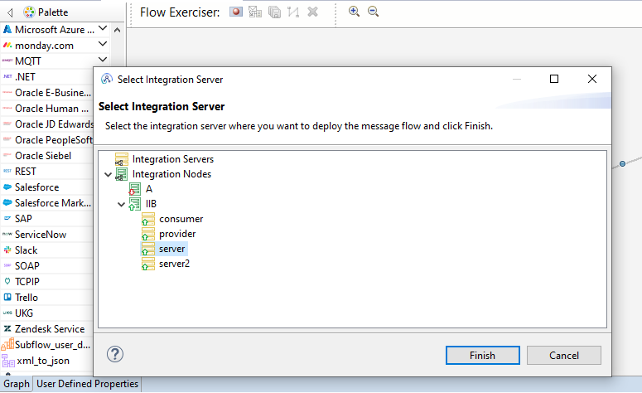

Click on the HTTP input node and select the send message option.

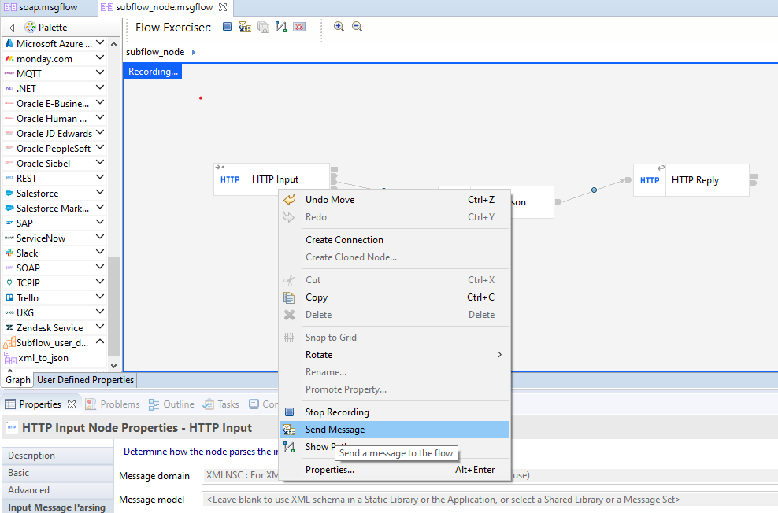

Create a sample xml message and then click on send. And see the output.

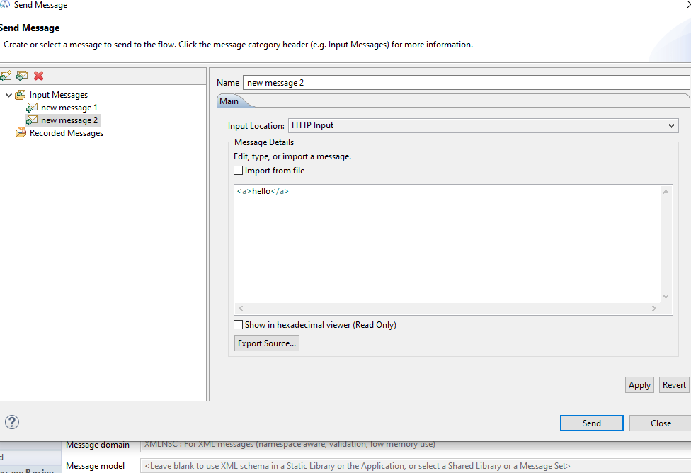

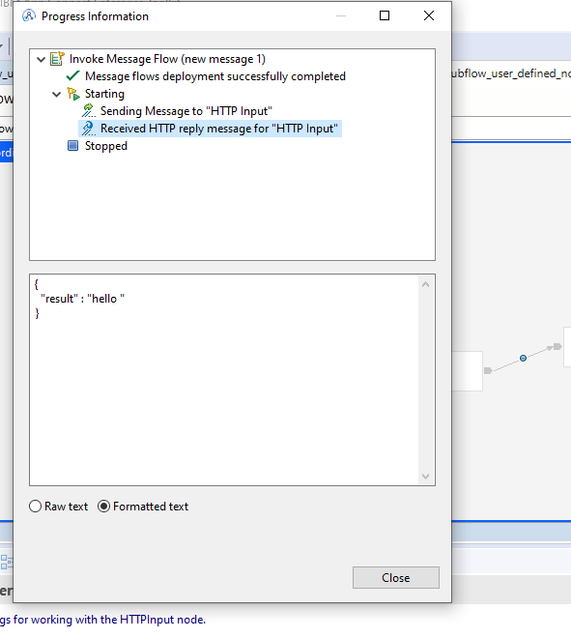

After getting the successful result create a package and give it to the Subflow user-defined-consumers.

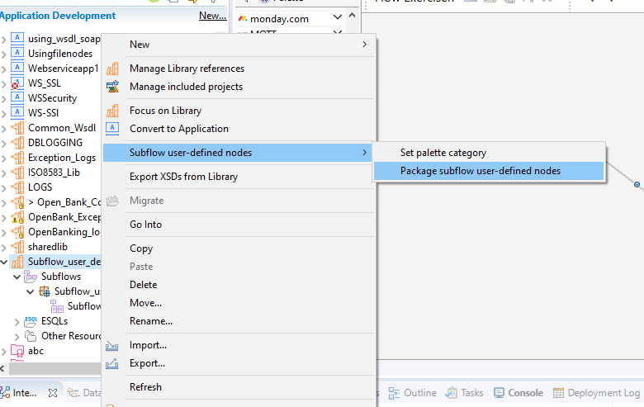

Browse the path where you want to create the .zip file. And then click on Finish.

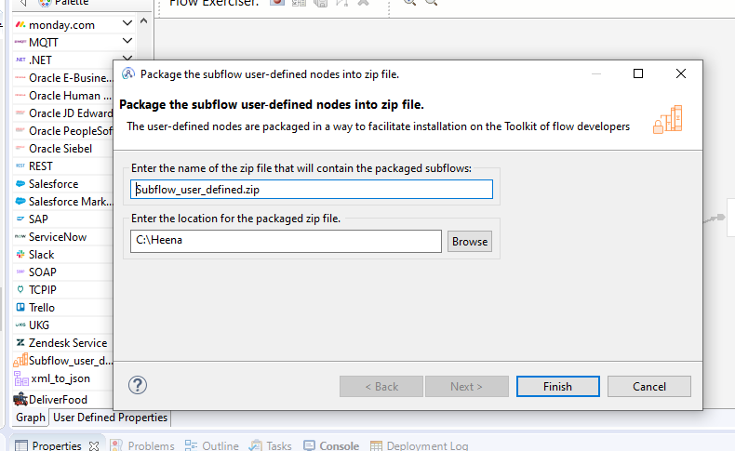

Go the project option and select Mange subflow user-defined libraries.

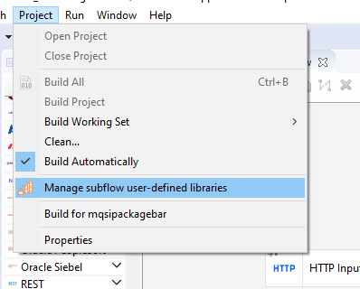

Click on Install option and select the .zip file location and then close.

